**Software Requirement Specification for**

**Advanced Hospital Management System**

**Version 1.0**

**Prepared by D.D.U.B.Wijerathna**

**2015/CS/152**

**15001522**

**25/05/2017**

**Introduction**

* **Purpose**

Advanced Hospital Management System is intended to help patients. So this document is to delineate the functionality and performance goals for the software project “Advanced Hospital Management System” in briefly, so as to serve as a guide to the developers on one hand and a software validation document for the prospective client (XYZ Hospital Staff) on the other.

* **Intended Audience and Reading Suggestions**

As this is a stand-alone application it is only available to XYZ hospital staff. Users should be registered to the system by the admin by filling up registration forms.

* **Project Scope**

The system will contain a database in order to store all information related to the Hospital staff, attendance of the staff, patients, test reports, appointments and bills.

An operational manual is provided to the system administrator which is a simple explanation of the system and its features.

**Functional Requirements**

**Admin**

Login to the System

Log out from the system

Register the Hospital staff to the system

**Doctor**

Login to the System

Log out from the system

View patients assigned to a particular doctor

View Appointments related to a particular doctor

**Receptionist**

Login to the System

Log out from the system

Mark the attendance of Hospital Staff

Make the list of appointment

Add admitted patients’ records

**Finance staff**

Login to the System

Log out from the system

Add payments details of each patient to the system

**Lab Assistant**

Login to the System

Log out from the system

Add test reports’ details of each patient to the system

**Non Functional Requirements**

Security

Reliability

Maintainability

**ER Diagram**

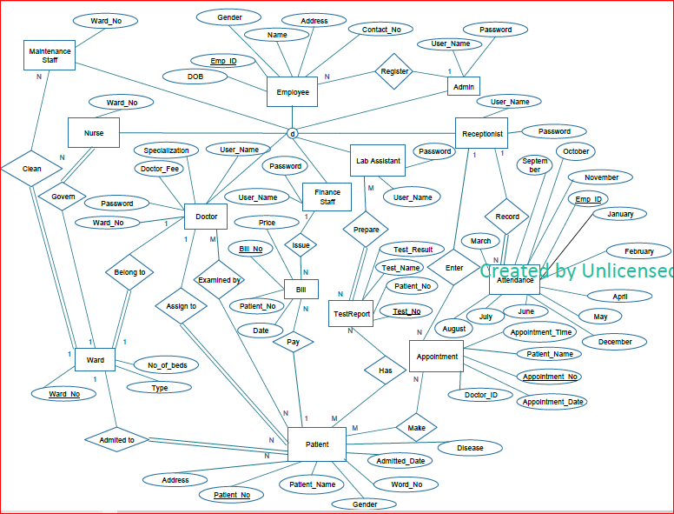

**Mapping to Tables**

Employee (Emp ID, Name, DOB, Gender, Contact No, Address)

Admin (Emp ID, User Name, Password)

Doctor (Emp ID, Specialization, Doctor Fee, User Name, Password, Ward No, Patient No)

Nurse (Emp ID, Ward No)

Ward (Ward No, No of beds, Type, Emp ID)

Maintenance Staff (Emp ID, Ward No)

Finance Staff (Emp ID, User Name, Password)

Receptionist (Emp ID, User Name, Password)

Attendance (Emp ID, January, February, March, April, May, June, July, August, September, October, November, December)

Appointment (Appointment No, Appointment Date, Appointment Time, Patient Name, Doctor ID, Emp ID)

Lab Assistant (Emp ID, User Name, Password)

Test (Test No, Test Name, Test Result, Emp ID, Patient No)

Patient (Patient No, Name, Address, DOB, Contact No, Gender, Disease, Admitted Date, Ward No)

Bill (Bill No, Price, Date, Patient No, Emp ID)

**Main Interfaces**

